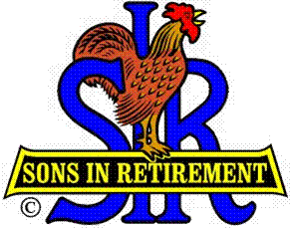**Las Trampas Branch 116**

**Luncheon Meeting Agenda**

**July 15, 2024, 11:30 AM**

**10:30** Social Hour

Greeters – Paul Ramacciotti, Joe Datz, Sheldon Lawrence

New Member Orientation – Dave Williams

**11:25**  Five Minute Call

**11:30** Call to order – Big SIR

Pledge of Allegiance – Big SIR

Invocation– Dick Chaffee

**11:30** Salad Served

**11:36** Storyteller – Garrett Romain

**11:42** Comment sheets – Big SIR

Introduce Attendance of Speaker – **Michael Barrington**

* New Members – **Mike DiMaggio**, Sponsor Rich Gerchow; **Stan Slivinski**, Sponsor Mike Corker; **Charles Collins**, Sponsor Don Schroeder

**11:46** Activity Reports - Mike Ward: Reports by Dick Kauffman, Rich Black, Jeff

Johnson, Bernie Wroblewski, Dick Chaffee, Greg Hughes

**12:00** Lunch

**12:20** Introduce Speaker – Little SIR

**12:22** Speaker - Michael Barrington

**12:52**  Speaker Thank You – Big SIR

**12:54** Raffle Drawing – Bob Huck, Ben Bryce

Birthday Drawing – Little SIR

**13:00** Sing Happy Birthday

Sing God Bless America

**13:03**  Closing Remarks – Big SIR

**13:04** Adjourn; Next Meeting, August 19, 2024